Create your own simple picture on the grid below and break it into shapes ready to transform.
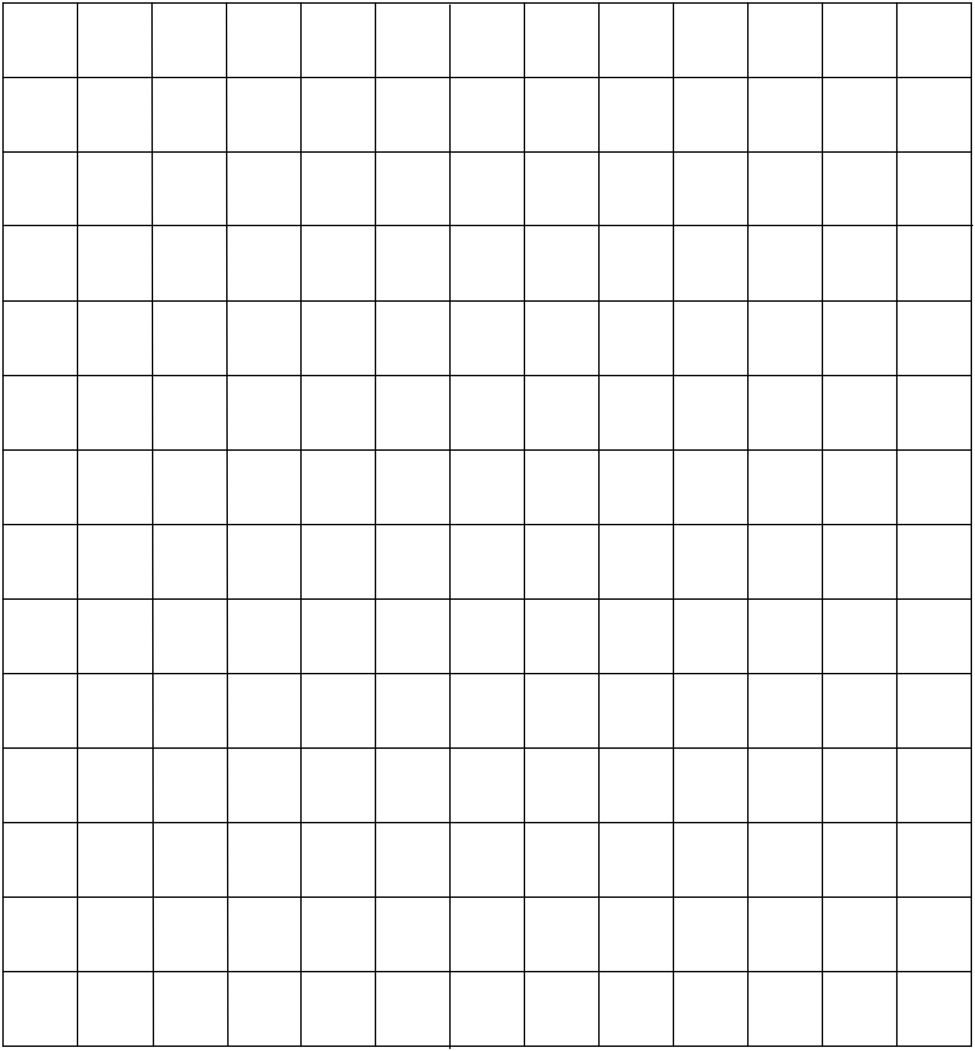Transform each shape out of position and write an instruction on how to transform it back into position.

Place your transformed shapes from Question 10 on the grid below and write the instructions underneath.
Give your grid to a friend in your class and ask them to follow the instructions to check that it works.
Attempt someone else’s drawing from your class.

